Chart showing **Male Vs Female, industry wide differences in salary.**

**Data taken from:**

1. [Taxation Statistics 2020-21 – Individuals Table 5: Selected items, by sex, state/territory and broad industry, 2020–21 income year](https://data.gov.au/data/dataset/07b51b39-254a-4177-8b4c-497f17eddb80/resource/4965b0a0-6202-46f9-b2a4-ae310cb6377f/download/ts21individual05sexstateterritorybroadindustry.xlsx)

South Australia.

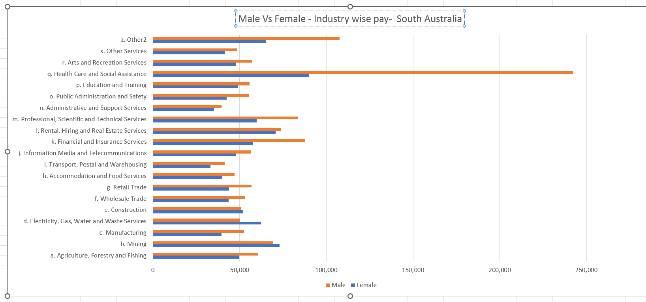

Western Australia

